<Customer logo>

<>

<>

AC Project #:

Business Requirements Document (BRD)

#### Release Information

|  |  |  |  |  |  |
| --- | --- | --- | --- | --- | --- |
|  | **Name** | **Designation/ Role** | **Location** | **Date** | **Sign** |
| **Prepared**  **By** |  |  |  |  |  |
| **Prepared By** |  |  |  |  |  |
| **Reviewed By** |  |  |  |  |  |
| **Approved By** |  |  |  |  |  |

# Table of Contents

Table of Contents 3

1. Introduction 4

1.1. Document Purpose 4

1.2. Intended Audience 4

1.3. Project Background 4

1.4. Purpose of the Business Requirements 4

1.5. Business Goals/Objectives to be achieved 5

1.6. Benefits/Rationale 5

1.7. Stakeholders 5

1.8. Dependencies on existing systems 5

1.9. References 5

1.10. Assumptions 5

2. Requirements Scope 5

2.1. In Scope 6

2.2. Out of Scope 6

3. Functional Requirements 6

3.1. Actor Profiles Specification 6

3.2. Essential Use Cases 7

4. Data Requirements 7

4.1. Data Architecture 7

4.1. Data Volumes 7

4.2. Data Conversion 7

4.3. Data Retention and Archiving 7

4.4. Privacy/Security Implications 8

5. Non-Functional requirements 8

5.1. Security Requirements 8

5.1.1. Authentication 8

5.2. Availability Requirements 8

5.3. Usability Requirements 8

5.4. System Help Requirements 8

5.5. Performance Requirements 8

5.6. Scalability Requirements 8

5.6.1. User Scalability 9

5.6.2. Application Scalability 9

6. Interface Requirements 9

6.1. User Interface Requirements 9

6.2. System Interface Requirements 9

7. Business Glossary 9

# Introduction

## Document Purpose

The purpose of this document is to describe business requirements of the Oak Hill Stables website completely, accurately and unambiguously in Technology-independent manner. All attempts have been made in using mostly business terminology and business language while describing the requirements in this document. Very minimal and commonly understood Technical terminology is used. **Use case** is used in modeling the business requirements in this document.

## Intended Audience

The main intended audience for this document are the business owners of the proposed system.

* Barney Edwards: Website Designer / Owner
* Meghan Edwards: Owner

## Project Background

Oak Hill Stables is a newly proposed horse boarding and riding stable in Shelbyville, KY. The owners would like to have a modern website.

Mention here briefly if these business requirements are as a result of any previous meetings, correspondence, legislations etc.

## Purpose of the Business Requirements

This section describes the purpose of the Business Requirements.

Tick one or more of the appropriate check boxes and describe the purpose of the Business requirements briefly underneath.

Business requirements for major enhancements to an existing application.

Business requirements for new application development.

Business requirements for replacement application development.

Business requirements for a request for proposals (RFP).

## Business Goals/Objectives to be achieved

This section describes the major goals/objectives to be achieved with the implementation of the Business Requirements.

State major business goals/objectives that the implementation of these Business Requirements will achieve. Avoid describing Technical goals.

## Benefits/Rationale

This section describes the major benefits to be achieved with the implementation of the Business Requirements.

State the major benefits that the implementation of these Business Requirements will result in. Mention both tangible and intangible benefits expected.

## Stakeholders

Stakeholders are the individuals or groups who have a vested interest in this project and whose interests need to be considered throughout the project. This section lists the Stakeholders of the Application / Project for which these Business requirements are documented.

List Stakeholders – that is, the individuals or groups who have a vested interest in this project and whose interests need to be considered throughout the project. Identify their roles in the project and commitment to the project.

## Dependencies on existing systems

This section describes the dependencies between the Application for which these Business Requirements are written and the other existing applications/systems.

Describe the dependencies between this Application (for which these Business Requirements are written) and other existing systems.

## References

This section lists the references to previous documentation, correspondence etc , if any, that are related to these Business Requirements.

List here all the external reference documentation, hyperlinks to web pages etc. that are directly related to these Business Requirements.

## Assumptions

This section describes major assumptions that were made prior to or during the Business Requirements gathering and documentation.

Describe major assumptions that were made (or exist) for these Business Requirements.

# Requirements Scope

This section shows what business functionality is in scope and out of scope for Implementation.

Include an overall high-level Use case diagram indicating which use cases are out of scope for Implementation. Draw separate boundary boxes around “in scope” use cases and “out of scope” use cases. See the example below :

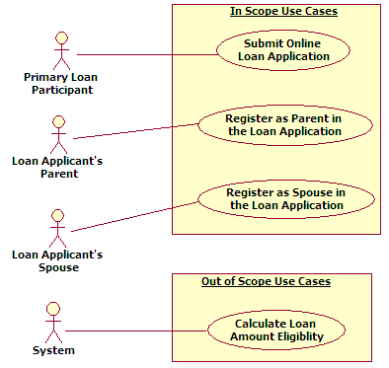

If Function Hierarchy Diagram (FHD) modeling is done for these Business Requirements, Include an overall high-level Function Hierarchy diagram indicating which Functions are out of scope for Implementation. Please draw the “out of scope” Function boxes in **grey** **color or a different color** as shown in the example below :

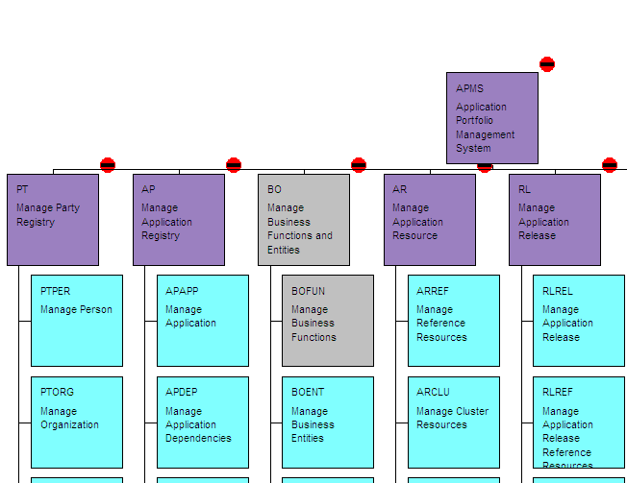

## In Scope

List the use cases/business functions that are **in scope**. Mention the name and a brief 2-3 lines short description for each use case/business function that is in scope.

List the system/organizational interfaces that are **in scope**. Mention the name and a brief 2-3 lines short description for each interface that is in scope.

## Out of Scope

List the use cases/business functions that are **out of scope**. Mention the name and a brief 2-3 lines short description for each use case/business function that is out of scope.

List the system/organizational interfaces that are **out of scope**. Mention the name and a brief 2-3 lines short description for each interface that is out of scope.

# Functional Requirements

This section describes the *Functional requirements* part of the Business Requirements. In Use case approach, the *Functional Requirements* comprises of Actor Profile Specification, Essential Use case diagram and Essential Use case specification in narrative text form.

## Actor Profiles Specification

This section describes all the Actors and their profiles within the context of the Business Requirements being documented. An Actor is a person, organization or an external system/sub-system/program that has interactions with the Application. Actors, by definition, are external to the system with which they are having interactions. Actors have goals that are achieved by use cases. Typically, Actors have behaviour and are represented by the roles they play in the use cases. An Actor stimulates the system by providing input and/or receiving something of measurable value from the system.

In Use case approach, please use the following template to document the Actor profiles for the

|  |  |  |  |
| --- | --- | --- | --- |
| **Actor Name** | Modules/Pages | Access Type needed | Comments |
|  |  | Create  Print  Read  Export  Update  Others  Delete |  |
|  |  | Create  Print  Read  Export  Update  Others  Delete |  |
|  |  | Create  Print  Read  Export  Update  Others  Delete |  |
|  |  | Create  Print  Read  Export  Update  Others  Delete |  |

## Essential Use Cases

This section is applicable only to Use case approach. This section depicts the Business Requirements in the form of Essential Use case diagram. In the Use case approach, the Functional Requirements are decomposed into a number of Essential Use cases. Essential use cases are of primary importance early in a project’s requirements/analysis phase. Their purpose is to document the business process that the Application must support without bias to technology and implementation.

Different use cases are to be specified in use case templates. A reference to repository where use case templates are stored to be provided.

Please include here the Essential Use Case Diagram for the Business Requirements. You may also provide additional context description below the diagram, if required.

If Use case approach is followed, please describe the business rules in the following Use case templates and provide a reference to the use case repository here.

# Data Requirements

This section describes the Data requirements part of the Business Requirements.

## Data Architecture

This section describes the Data Architectural requirements part of the Business Requirements.

## Data Volumes

This section describes the expected approximate Data volumes (initial volume and annual growth %).

## Data Conversion

This section describes the high-level Data Conversion Requirements.

## Data Retention and Archiving

This section describes the Data retention (time frames for online Data retention before archiving) and also the archiving requirements.

Please describe the time frames in number of years/months/days for online Data retention before the data is archived and purged.

Please describe if there are any other special data archiving requirements exist and the PIA/FOI and other compliance issues that need to be taken into consideration during data archival and for the archived data.

## Privacy/Security Implications

This section describes the sensitivity levels of data. The following criteria are used in determining the sensitivity level of data

# Non-Functional requirements

This section describes the non-functional requirements part of the Business Requirements. A non-functional requirement is typically a special requirement that is not easily or naturally specified in the text of the use case’s or function’s event flow. Examples of non-functional requirements include legal and regulatory requirements, application standards, and quality attributes of the system to be built including usability, reliability, performance or supportability requirements.

## Security Requirements

This section describes the Security requirements part of the Business Requirements.

### Authentication

This section describes the Authentication requirements part of the Business Requirements. Authentication is the process of verifying the genuineness of claims that a person/group makes to establish identity/eligibility for access to services.

Examples of Authentication requirements are : OAuth, Single sign on used for external apps, Two-factor authentication, Password requirement, Shared accounts (allow multiple people to use the same username and password) etc., Reference:

http://www.bu.edu/tech/about/policies/info-security/1-2-c-access-management-and-authentication-requirements/

## Availability Requirements

This section describes the system availability requirements – 24 x 7, acceptable downtime etc.,

## Usability Requirements

This section describes the system usability requirements. A usability requirement specifies how easy the system must be to use. Usability is a non-functional requirement, because in its essence it doesn't specify parts of the system functionality, but specifies only how that functionality is to be perceived by the user, for instance how easy it must be to learn and operate the system.

Please describe the expectation levels of various usability factors for the system. Examples of usability factors are : Ease of learning, task efficiency, understandability, subjective satisfaction, Target users’ technical expertise levels, education levels etc.

## System Help Requirements

This section describes what kind of System Help features are needed to be built into the system. Do we provide help documentation? If so – would this be through an external system? Is there any Help desk that the end user can connect to? If so, would there be an external helpdesk system?

## Performance Requirements

This section describes system performance expectation levels – response times, workload for the system to manage. This can defer for each use case or functional module – If so, these have to be mentioned in the use case.

## Scalability Requirements

This section describes how the system is expected to scale to new higher or lower levels. Both user and application scalability requirements are described here. *Data scalability is not described here as it is already described in the “data volumes” section earlier*.

### User Scalability

Please describe how the user volumes are likely to grow in a given number of months or years. Example : 1000 new users are expected to use this internet system in the next 6 months.

### Application Scalability

Please describe if any new major functionality/interface is likely to be added to the application in the next given number of months or years. Example : This system will have a new public facing (internet) interface in the next 1 year.

# Interface Requirements

This section describes User and System Interface requirements for the proposed system.

## User Interface Requirements

Any particular theme color principles to follow, various screen resolutions to support

## System Interface Requirements

Please list and describe here what other external systems/business functions are required to be interfaced with the proposed system from Business Requirements perspective. Example : This system needs to interface with the CAS in order to receive some input data. Please avoid describing system design and technical issues.

# Business Glossary

Please include here complete glossary of business terms used in this document.